1. Read and print your name

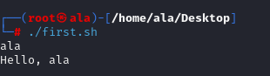

Answer:

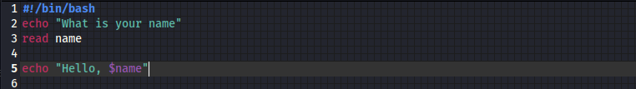

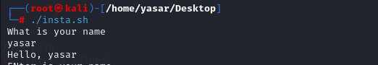

1. Get the multiple inputs using single read command

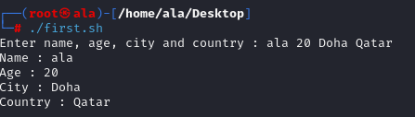

Answer:

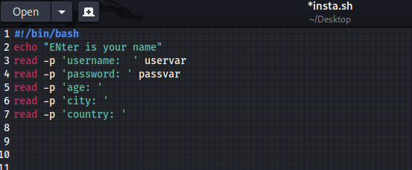

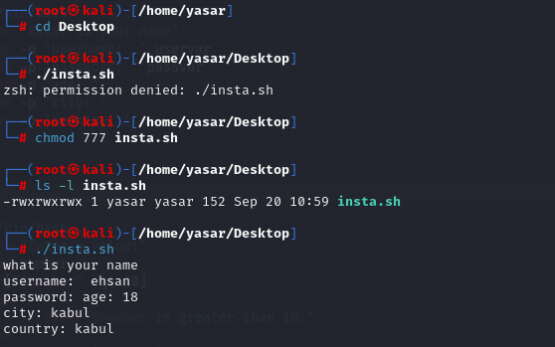

1. Write a program to check If the input is greater than 10

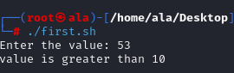

Answer:

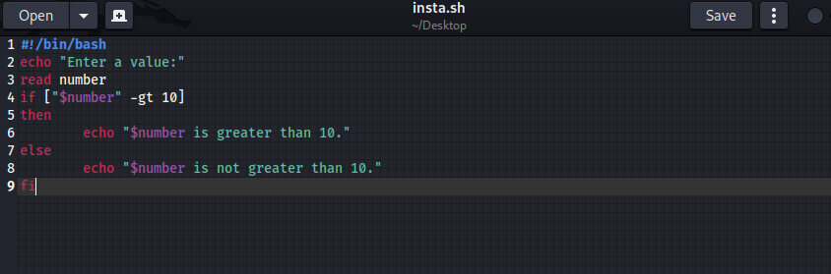

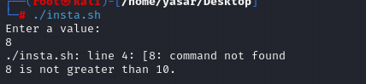

1. Write a script to ask the user for a directory name. Then, it create the directory and cd into it.

